**Practical 3 Devops:**

**Steps :-**

1. Install Jenkins in your system.

**Note: you can refer to any youtube or geekforgeeks website**

1. Now login to your Jenkins server site at <http://localhost:8080>
2. Click on New Item.

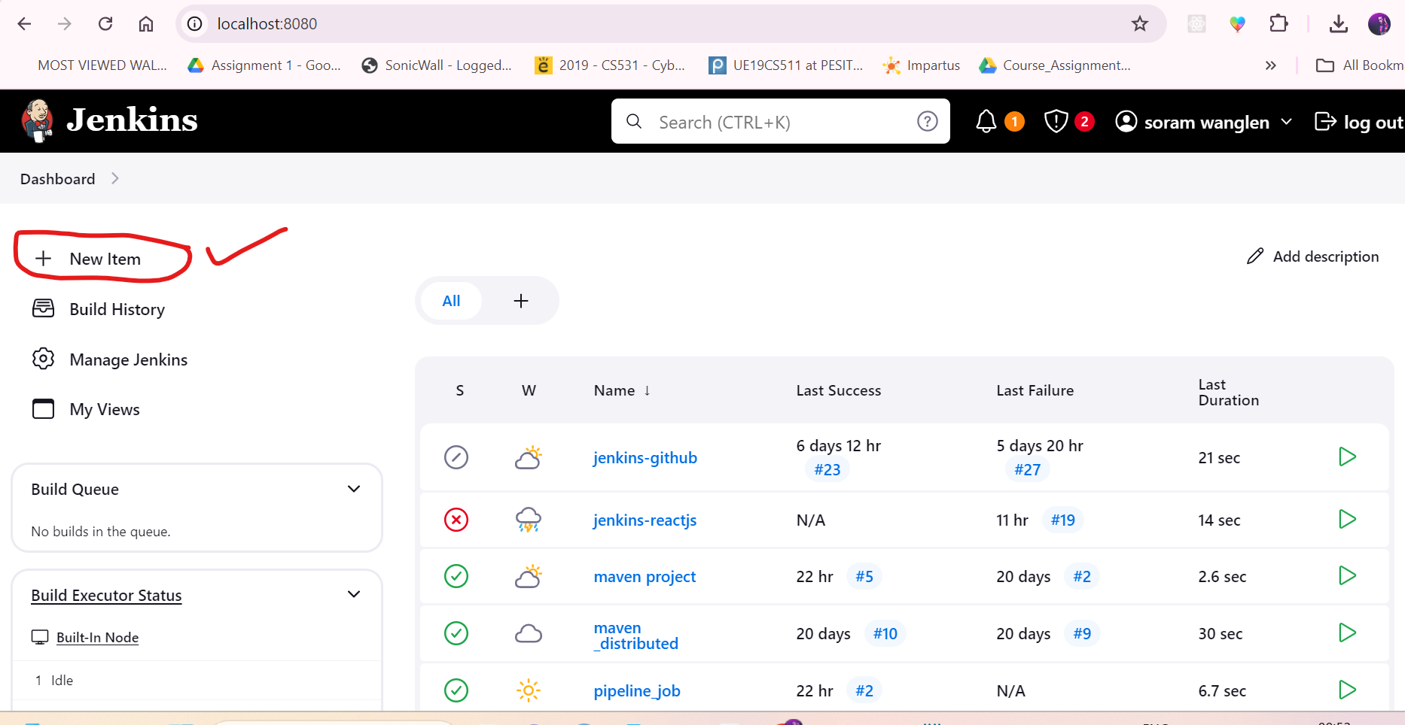

1. Now type your string and click on freestyle project and ok.

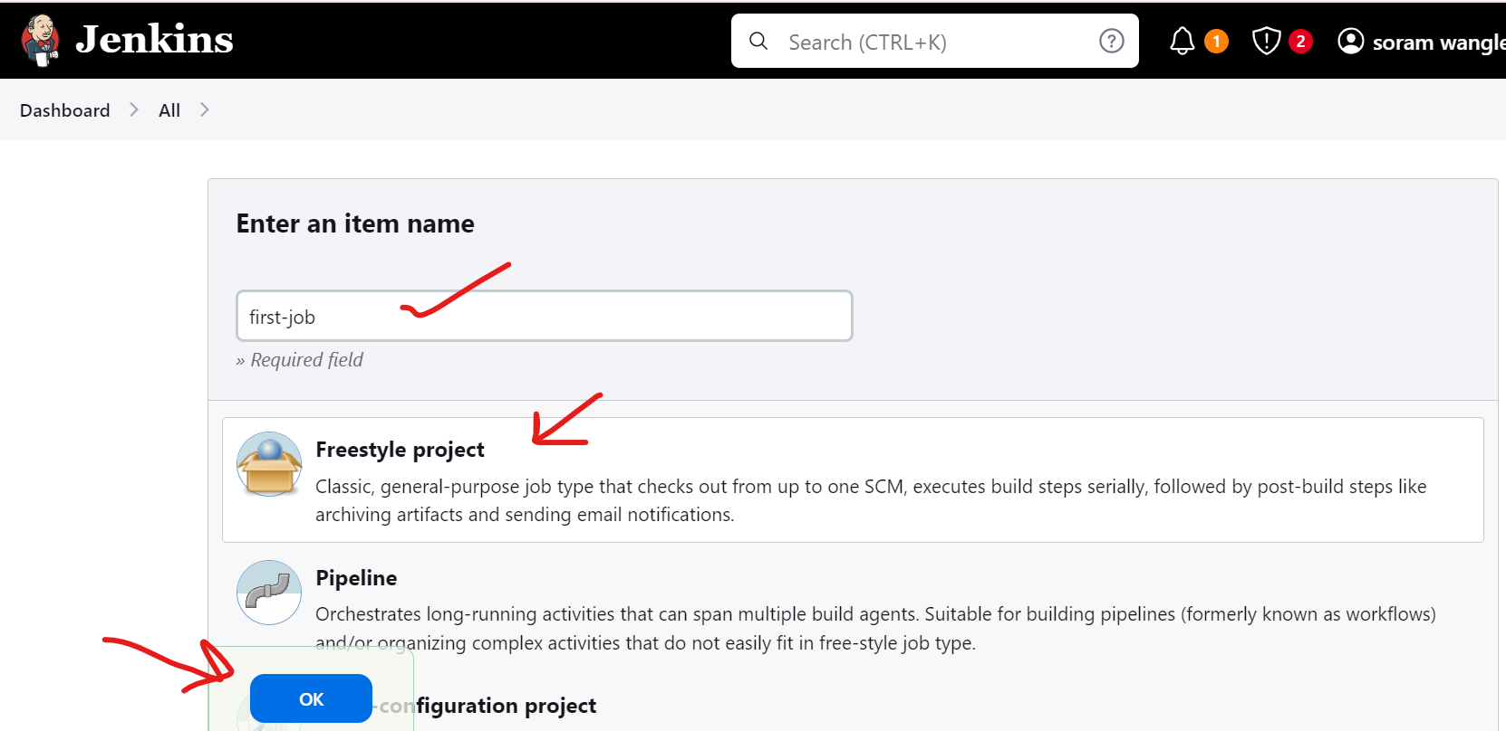

1. **After creating the job or new item goto that and click on configure.**

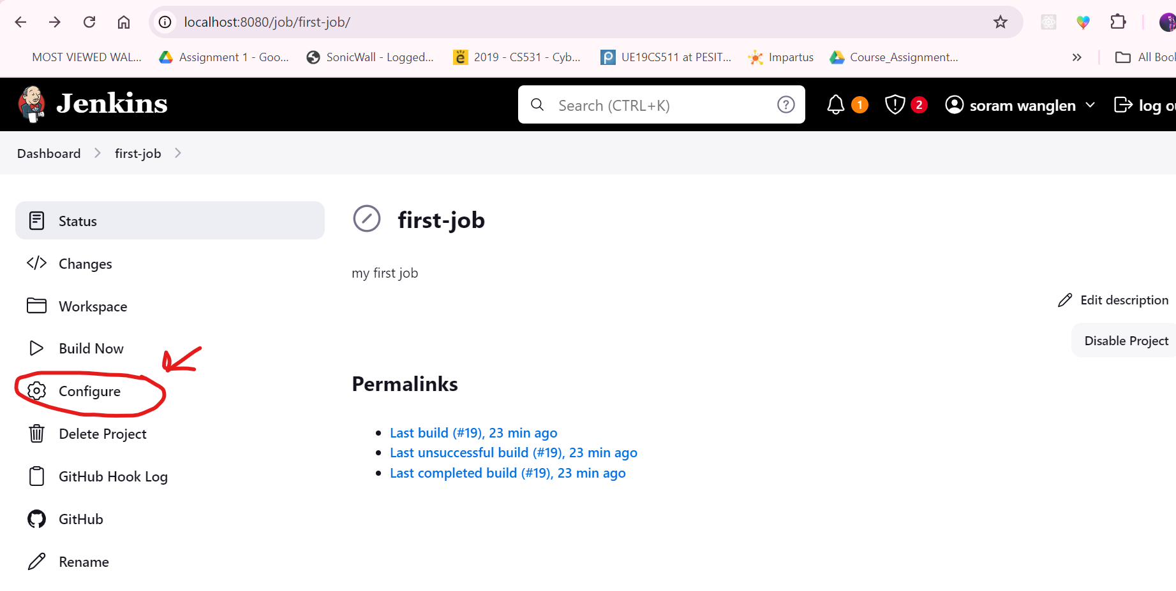

**1.Project name**: Set the name for your Jenkins job.

**2.Description**: Optionally, add a description for the job.

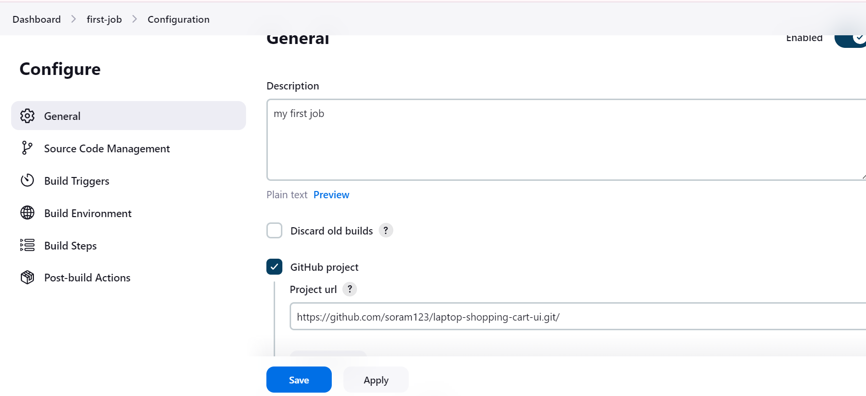

* 1. **Create a custom working directory if you already have a working directory.**

**Note : The folder will be empty but once build is run it will populate the folder with the files from github.**

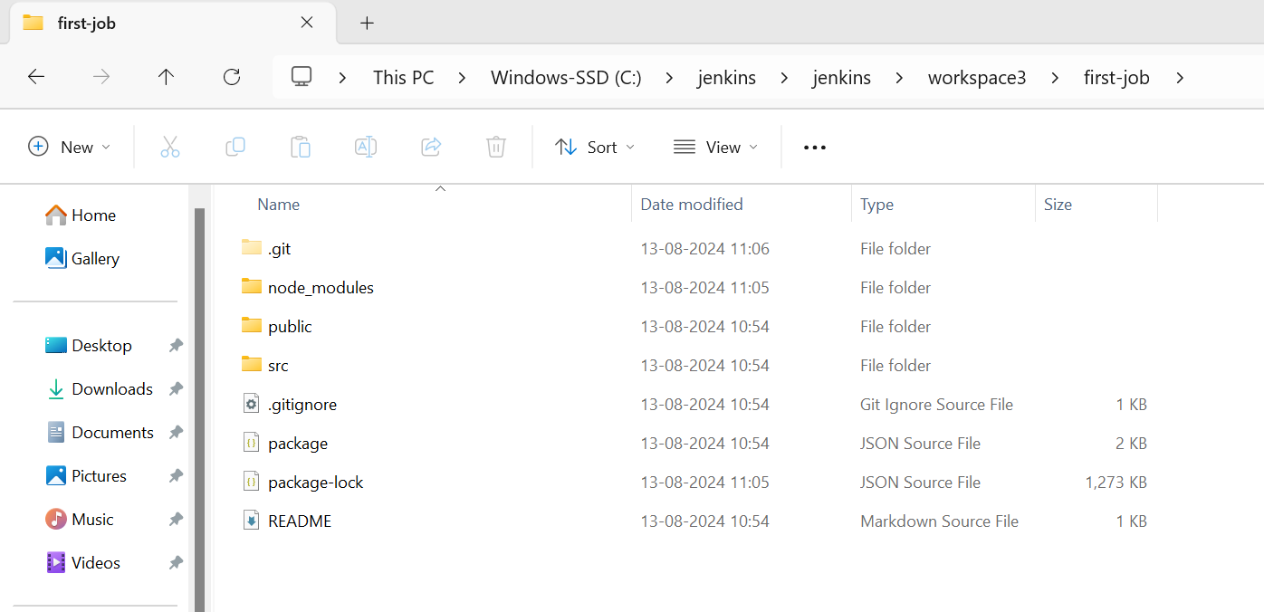

* 1. **Now goto the advanced section and add this under custom directory.**

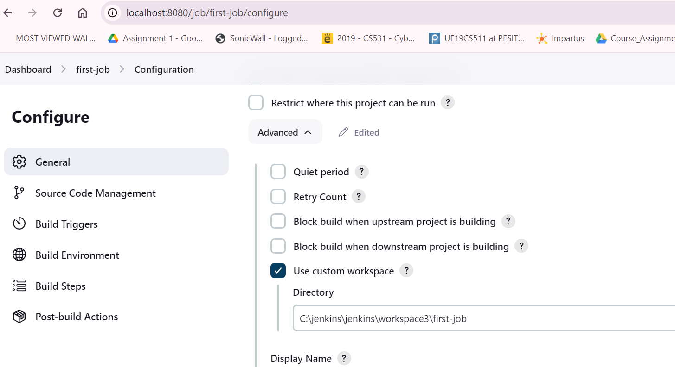

### 6. ****Source Code Management****

1. **Git**:
   1. **Repository URL**: https://github.com/soram123/laptop-shopping-cart-ui.git

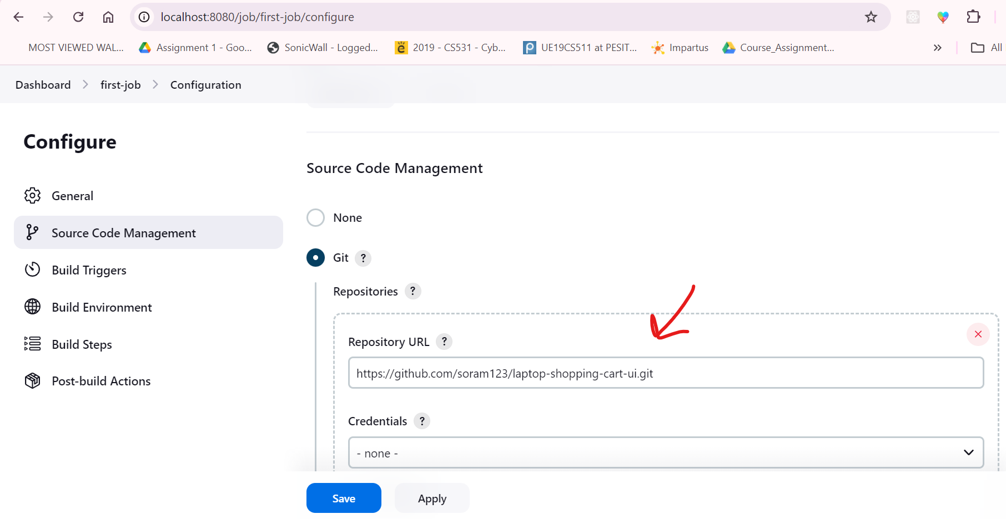

**Note: no need to add any credentials if github repo is kept public.**

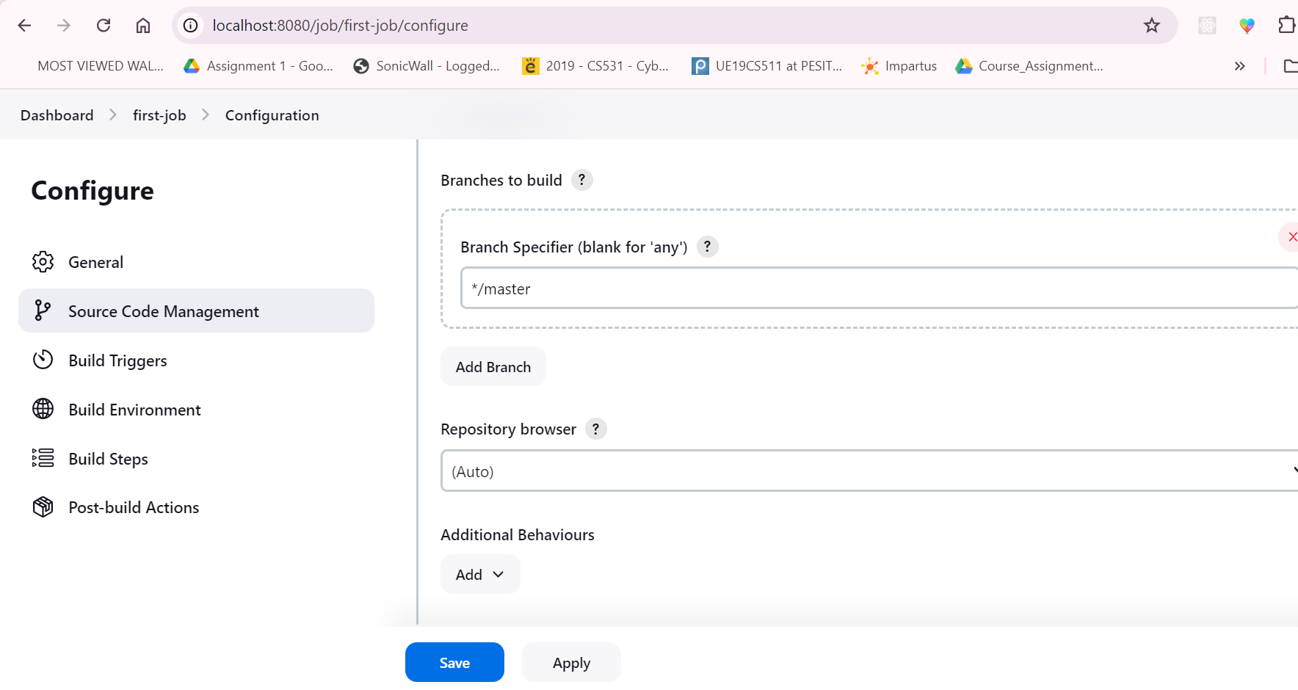

**Based on the github branch you can add here.**

1. **Build Triggers**

**Set up any build triggers if needed (e.g., Poll SCM, GitHub hook trigger).**

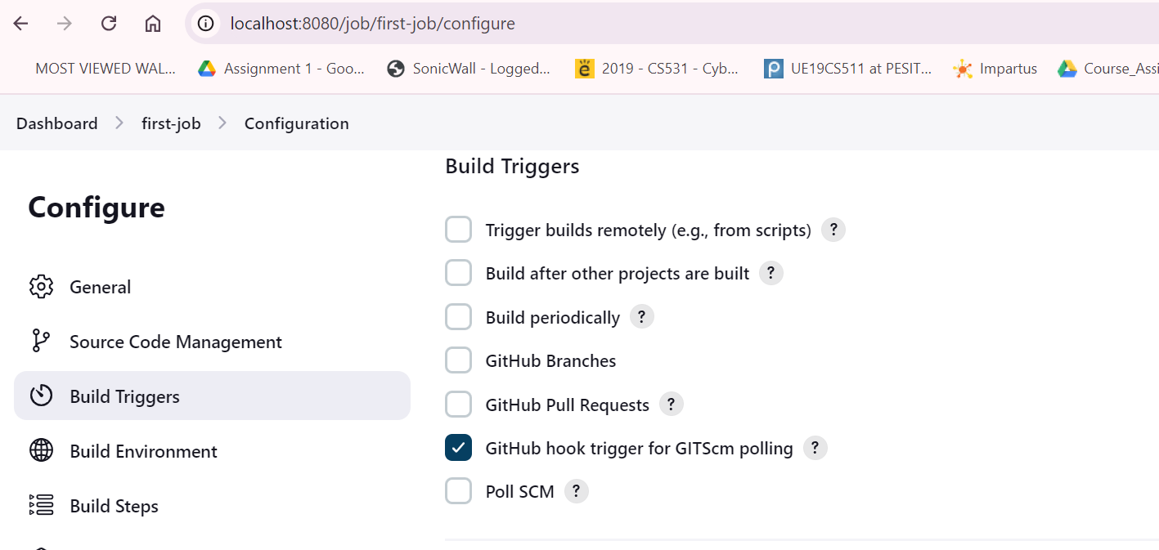

1. **Build Environment and Building the application.**

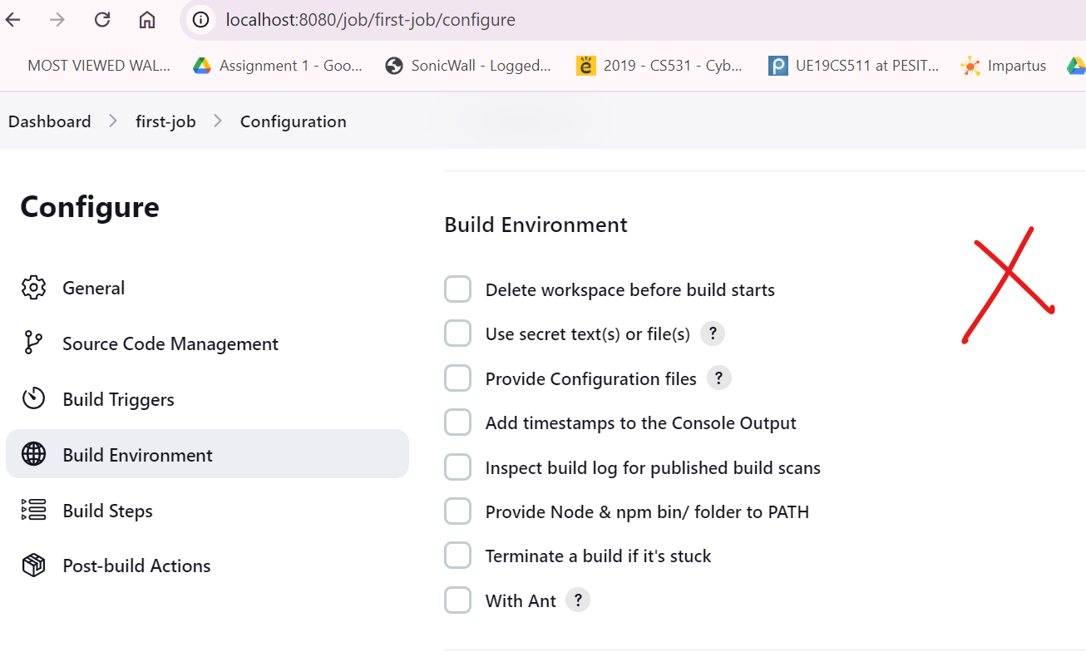

**Note: no need of this.**

1. **Build the application running the below commands.**

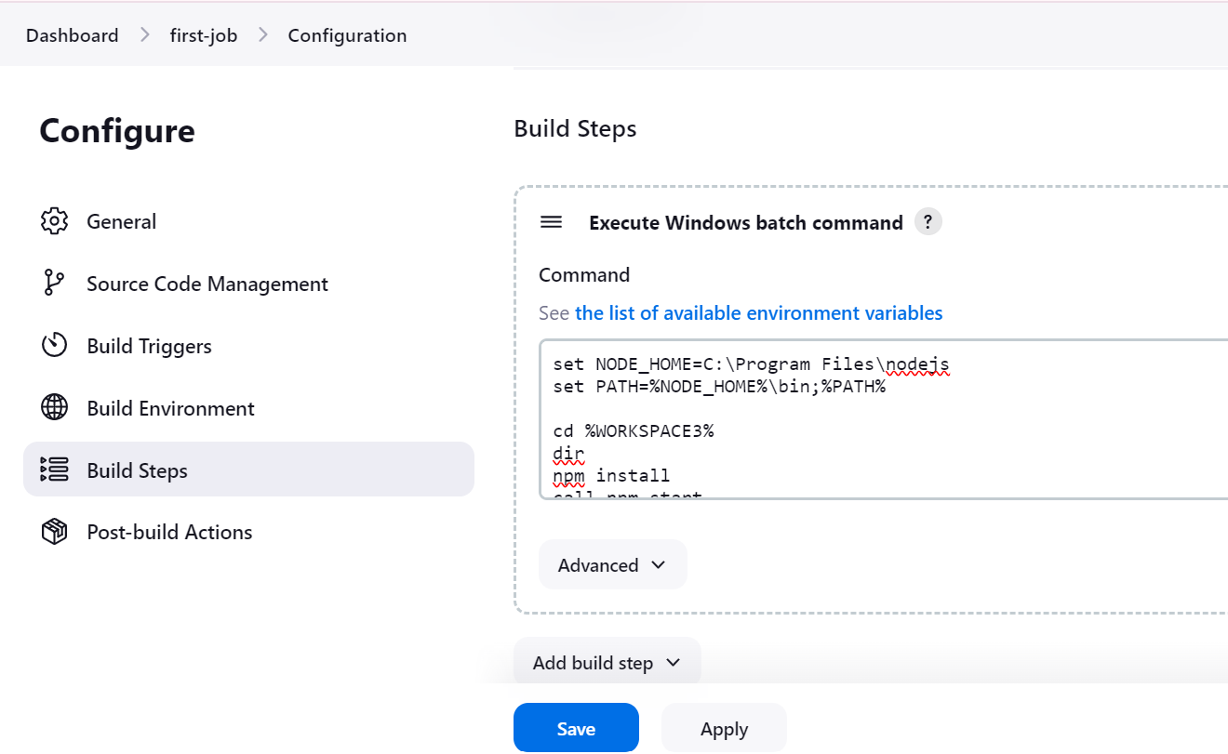

1. **Commands in windows Jenkins to run the reactjs application.**

set NODE_HOME=C:\Program Files\nodejs

set PATH=%NODE_HOME%\bin;%PATH%

cd %WORKSPACE3%

dir

npm install

call npm start

1. Now after applying and saving the above steps click on build.

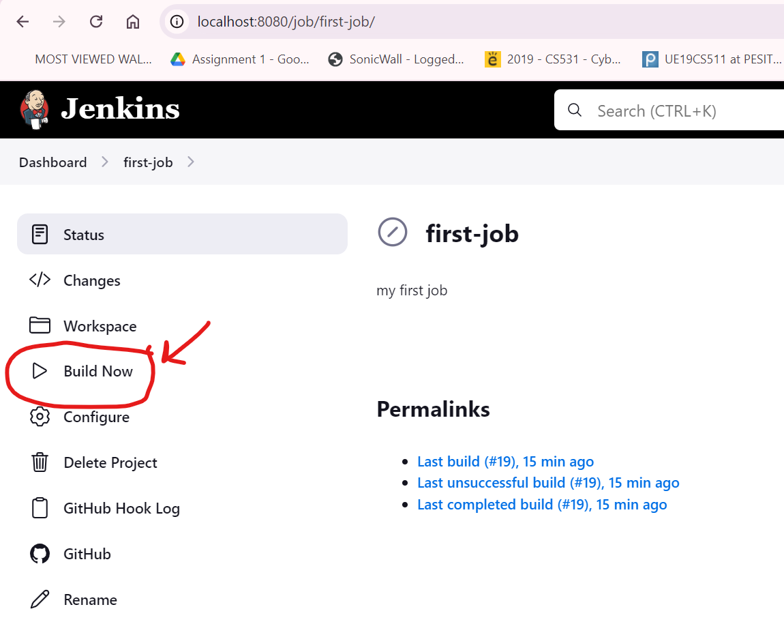

1. Now click on the job down arrow bottom and select ‘console output’ .

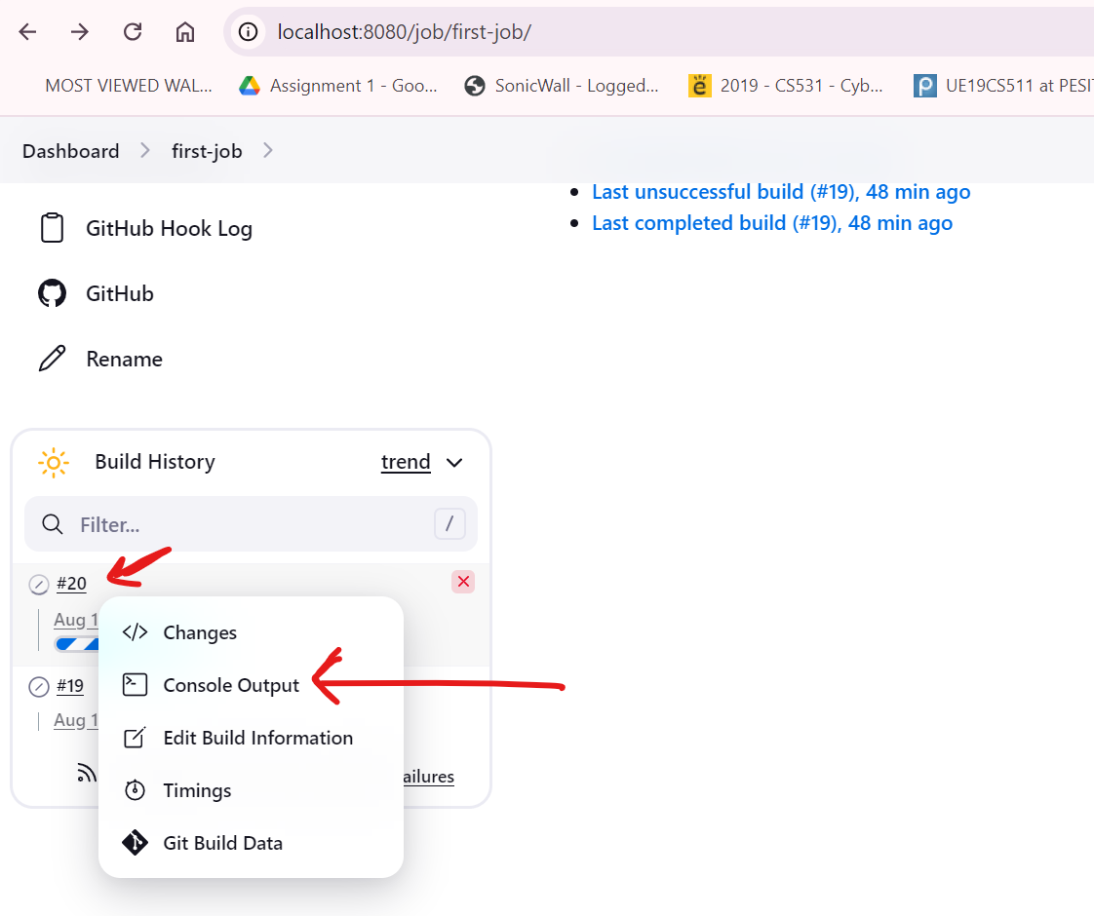

1. Here you can see it is running.

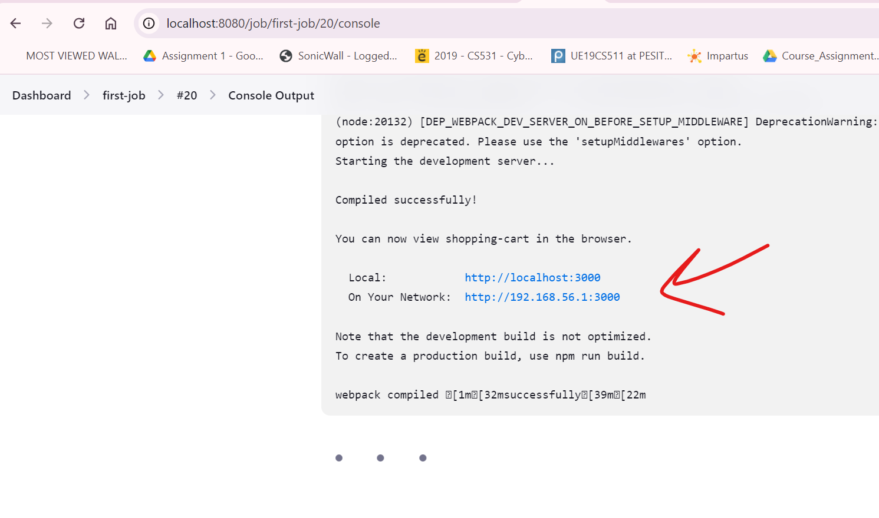

1. Finally click on that link and it will open in your browser.

